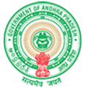
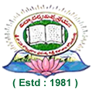

S. V. B. GOVERNMENT DEGREE COLLEGE,

Koilkuntla

(Affiliated to Rayalaseema University, Kurnool, A.P.)

Accreditation by NAAC By with "B+

LINK TO ACADEMIC CALENDARS
Following is the link to Academic calendars displayed on institutional website

https://www.svbgdckoilkuntla.ac.in/pages.php?type=academics&id=academic-calendar

